 | WEDNESDAY | THURSDAY | FRIDAY | SATURDAY | SUNDAY | MONDAY
MORNING | Arrival of participants. Everybody must check in before 17:00  18:30 WORKSHOPS | Opening Ceremony (9:00)  Working sessions  Coffee Break (11:00)  Working sessions  Lunch  (14:00 – 16:00)  Working sessions  (16:00 – 18:30) | Working sessions (9:00 – 11:00)  Coffee Break  Working sessions  Lunch  (14:00 – 16:00)  Working sessions  (16:00 – 18:30) | Working sessions (9:00 – 11:00)  Coffee Break  Working sessions  Lunch  (14:00 – 16:00)  Closing Ceremony  (16:00 – 18:00) | Departure of some participants  (check out at the hostel is at midday, but they will store your luggage there safely until you leave the city)  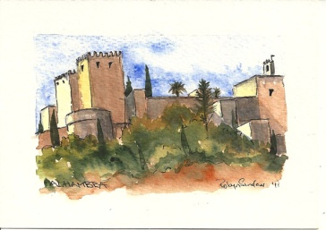  Visit to  La Alhambra  (12:00 – 13:00 – 13:30) | 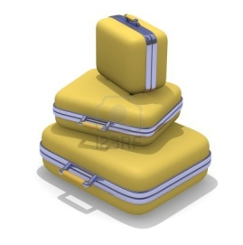Departure of all participants (check out at the hostel is at midday, but they will store your luggage there safely until you leave the city)
EVENING
NIGHT | Welcome Dinner!  (20:30) | International Dinner!  (20:30) | Tapas Night  (20: 30) | Farewell Dinner  (20:30)
MODEL EUROPEAN UNION GRANADA 2014

